DIRECTIONAL COUPLER

Objective: To measure the directivity and coupling factor of a directional coupler

List of Equipment
- Microwave source with square wave modulation
- Isolator
- Variable attenuator
- Slotted line
- Directional Coupler
- Tunable detector
- VSWR meter
Theory:
A directional coupler is a four-port microwave junction with the properties described below. With reference to Fig.1, which is schematic illustration of a directional coupler, the ideal directional coupler has the property that a wave incident in part 1 couples power into ports 2 and 3 but not into part 4. Similarly, power incident in part 4 couples into ports 2 and 3 but not into part 1. Thus ports 1 and 4 are uncoupled. For wave incident in port 2 or 3, the power also uncoupled. In addition, all four ports are matched. That is, if three ports are terminated in matched loads, the fourth port appears terminated in a matched load, and an incident wave in this port suffers no reflection.
Directional couplers are widely used in impedance bridges for microwave measurements and for power monitoring. Since these devices are required to operate over a band of frequencies, it is not possible to obtain ideal performance over the whole frequency band. The performance of a directional coupler is measured by two parameters –coupling and directivity. Let  be the incident power in port 1 and left 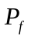be the coupled power in the forward direction in port 3. The coupling in decibels is then given by
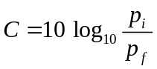
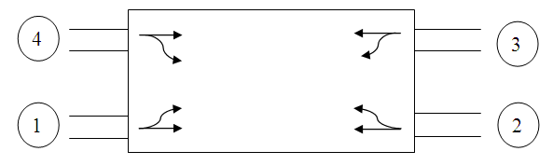
Figure 1
Ideally, the power 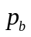coupled in the backward direction in arm 4 should be zero. The extent to which this is achieved is measured by the directivity D, which is defined as
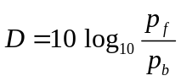
The directivity is a measure of how well the power can be coupled in the desired direction in the second waveguide.
A number of properties of the ideal directional coupler may be deduced from the symmetry and unitary properties of its scattering matrix.
The directional couplers are designed for a wide range of coupling factors, e.g., 3db, 10 db, 20db, 30db etc. The directivity of good coupler is about 30db. There is a great variety of ways of constructing directional couplers. A common type of directional coupler consists of two waveguides with suitable coupling apertures located in a common wall. With reference to Fig.1, sometimes, one of the ports, the port isolated from the input port, may be permanently match-terminated and therefore become inaccessible for any connections. A coupler is called a dual directional coupler when all four ports are accessible for connections.
Source
Variable Attenuator
Wave
Meter
Slotted Line
Detector
VSWR Meter
(x)

For connection at (x) the following are required
  - Directional Couplers
  - Three Matched Terminations
  - Waveguide crystal Detector with VSWR meter or Power meter with probe.

Procedure:
1) Find the departure form perfect match, by cyclically feeding power to one port and terminating other ports in matched loads. For example
- Connect port 1 to bench at X and terminate 2, 3, 4 in matched loads. Plot a curve VSWR vs frequency (9 to 11 GHz).
- Connect port 2 to bench at X and terminate 3, 4,1 in matched loads and repeat (i) and so on.
II) Coupling and Directivity Measurement
- Connect port 1 to X point of the bench. Connect matched termination to port 2 and 4. Connect power meter to 3. Measure the output power i.e. 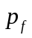.
- Remove the directional coupler assembly, connect power meter directly to X and hence find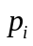.
- Do this for at least ten frequencies in the 9 to 11 GHz range. Plot Coupling factor vs frequency.
- While doing part (i), one can interchange power meter and matched load for ports 3 and 4 to find. Do it for all the ten frequencies. Hence plot Directivity vs frequency.

III) By the same procedure as in II, verify the specifications of two directional couplers.
Explain the various results obtained.

Discussion:
- How does coupling occur in Directional Coupler?
- How does the size and shape of hole affect the function of coupler?
- What is forward and backward directional coupler? Explain working of phase difference coupler?
- How do the directivity and the coupling factor of coupler vary with frequency?

References:
- R.E. Collin, ‘Foundations for Microwave Engineering’, 1966.
- K.C. Gupta, ‘Microwaves’, 1978.
- R. Chatterjee, ‘Elements of Microwave Engineering’, 1984.

